

Name: Muhammad Faisal
Roll no: 2022F-BCS-152

Section: C
Instructor Name: Miss Sabeen
Course: Database Management Systems Lab (DBMS)
Program: (BS) - Computer Science

Lab #01

Introduction to Database and Microsoft SQL Server

Task 1: Installation of Microsoft SQL Server.
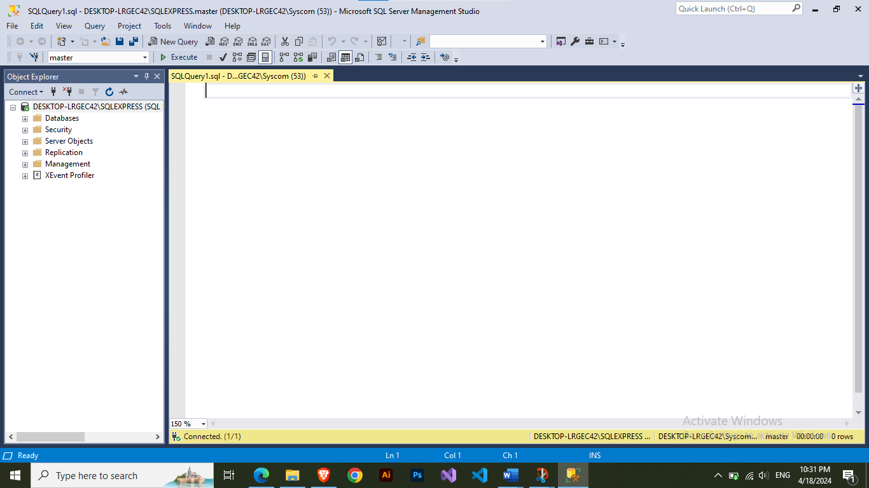

Microsoft SQL server management studio

Lab #02

Data Definition Operations and to become familiar with data
definition language.

Task 1: Create a new table Person and insert at least 5 records

Code:

CREATE TABLE Person(
CNIC INT PRIMARY KEY,
Name VARCHAR(50),
Age INT,
Nationality VARCHAR(50),
Gender VARCHAR(10),
);

INSERT INTO Person Values(42301, 'Faisal', 20, 'Pakistani', 'Male');
INSERT INTO Person Values(42302, 'Bilal', 20, 'Pakistani', 'Male');
INSERT INTO Person Values(42303, 'Furqan', 21, 'Pakistani', 'Male');
INSERT INTO Person Values(42304, 'Farhan', 22, 'Pakistani', 'Male');
INSERT INTO Person Values(42305, 'Ahsan', 19, 'Pakistani', 'Male');

Results:
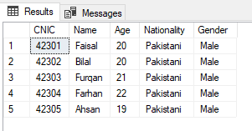

Task 2: Create a new table Customer and insert at least 5 records.

Code:

CREATE TABLE Customer (
customer_id INT PRIMARY KEY,
full_name VARCHAR(100),
date_of_birth DATE,
gender VARCHAR(10),
address VARCHAR(255)
);

INSERT INTO Customer VALUES
(1, 'Faisal', '2003-03-03', 'Male', 'Bahdurabad, Karachi'),
(2, 'Bilal', '2004-09-20', 'Male', 'Burns Road, Karachi'),
(3, 'Furqan', '2002-03-10', 'Male', 'Bahdurabad, Karachi'),
(4, 'Farhan', '2004-11-28', 'Male', 'Saddar, Karachi'),
(5, 'Ahsan', '2000-07-03', 'Male', 'DHA, Karachi')
Results:
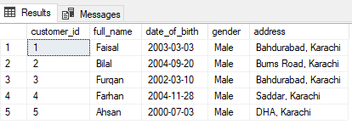

Task 3: Create a new table Order and insert at least 5 records

Code:

CREATE TABLE Orders(
order_id INT PRIMARY KEY,
customer_id INT,
order_date DATE,
product_name VARCHAR(255),
quantity INT,
total_price INT,
FOREIGN KEY (customer_id) REFERENCES Customer(customer_id)
);

INSERT INTO Orders VALUES
(1, 1, '2024-03-28', 'Laptop', 1, 1200),
(2, 2, '2024-03-27', 'Smartphone', 2, 800),
(3, 3, '2024-03-26', 'Headphones', 1, 100),
(4, 1, '2024-03-25', 'Tablet', 1, 500),
(5, 4, '2024-03-24', 'Speaker', 1, 150);

Results:
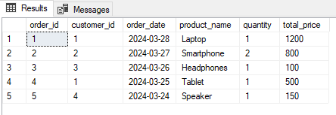

Task 4: Add a new field in the Person table.

Code:
ALTER TABLE Person
ADD Email VARCHAR(100);

Task 5: Modify any field in the Person table

Code:

UPDATE Person
SET Email = 'faisal@gmail.com'
WHERE CNIC = 42301;

UPDATE Person
SET Email = 'bilal@gmail.com'
WHERE CNIC = 42302;

UPDATE Person
SET Email = 'furqan@gmail.com'
WHERE CNIC = 42303;

UPDATE Person
SET Email = 'farhan@gmail.com'
WHERE CNIC = 42304;

UPDATE Person
SET Email = 'ahsan@gmail.com'
WHERE CNIC = 42305;

Results:
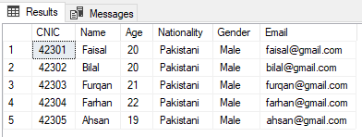

Task 6: Use some constraints in your queries.

Code:

CREATE TABLE Employee (
emp_num INT,
emp_name VARCHAR(10) NOT NULL,
dept_num INT NOT NULL,
email VARCHAR(50),
CONSTRAINT emp_pk PRIMARY KEY (emp_num),
CONSTRAINT deptno_positive CHECK (dept_num > 0 AND dept_num < 10),
CONSTRAINT emp_email_unique UNIQUE (email)
);

INSERT INTO Employee VALUES (1, 'Faisal', 5, 'faisal@gmail.com');

Results:

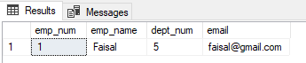

Lab #03

Introduction to Data Manipulation Language with
Insert ,Update and Delete Command
TASK 1:
- Insert new employee’s records.

Code:

CREATE TABLE emp(
empid INT PRIMARY KEY,
deptno INT FOREIGN KEY (deptno) REFERENCES dept (deptno),
empname VARCHAR(50),
empsalary DECIMAL(7,2),
empprofession VARCHAR(50),
emphiredate DATE,
);

INSERT INTO emp VALUES
(1001,50,'Smith',500,'Clerk','2002-04-02'),
(1002,20,'Faisal',5000,'Manager','2001-02-01'),
(1003,50,'Ahmed',900,'Driver','1980-12-21'),
(1004,52,'Farhan',900,'Sales person','1991-10-21'),
(1005,50,'Furqan',2000,'Graphic Designer','1999-11-21')
;

Results:
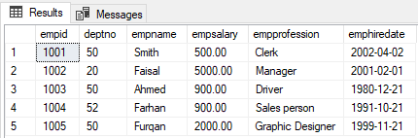

- Insert new department records deptno=50, dname=ADVERTISING and loc=MIAMI.

Code:

CREATE TABLE dept(
deptno INT PRIMARY KEY,
deptname VARCHAR(50),
deptloc VARCHAR(50),
commission DECIMAL(10, 2)
);

INSERT INTO dept VALUES
(50,'Advertising','MIAMI',500),
(20,'HR','MIAMI',700),
(52,'Sales','MIAMI',300);
Results:
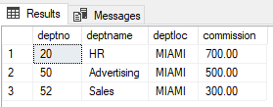

- Delete the records of Sales department
Code:
DELETE FROM emp WHERE deptno = (SELECT deptno FROM dept WHERE deptname = 'Sales');
DELETE FROM dept WHERE deptname = 'Sales';

Results:
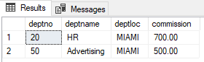

- Change the employees sal for Smith
Code:
UPDATE emp SET empsalary = 600 WHERE empname = 'Smith';

Results:
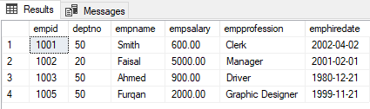

- Confirm all these changes by using Select statement

Code:
SELECT * FROM emp;
SELECT * FROM dept;
Results:
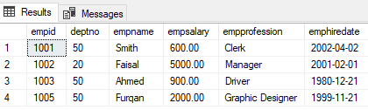

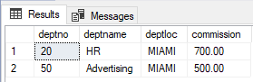

- Change the salary to $1,000 for all employees with a salary less than $900.
Code:
update emp set empsalary=1000 where empsalary<900;

Results:
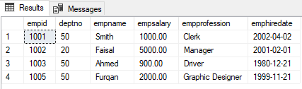

- Update the salary of each employee to 5000.
Code:
update emp set empsalary=5000;

Results:
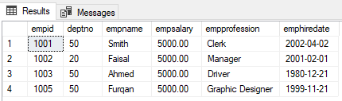

- Change the commission of department 20 to 1000.

Code:
UPDATE dept SET commission = 1000 WHERE deptno = 20;

Results:
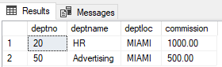

- Change the hire date of all clerks to 02-04-2000
Code:
update emp set emphiredate='2000-04-02' where empprofession='Clerk';

Results:
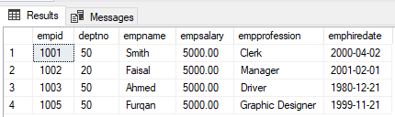

- Delete all the records having hire date before 21-dec-81

Code:
delete emp where emphiredate<'1981-12-21';

Results:
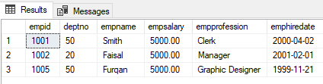

- Delete all records where salary is greater than 2000.

Code:
DELETE FROM emp WHERE empsalary > 2000;

Results:
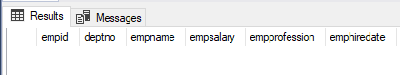

TASK2:

- Use insert, update & delete commands in 10 different scenarios.

CREATE TABLE Student (
student_id INT PRIMARY KEY,
student_name VARCHAR(50),
age INT,
grade VARCHAR(10),
address VARCHAR(100));
Scenario 1: Inserting a new student record:

Code:
INSERT INTO Student (student_id, student_name, age, grade, address)
VALUES (1, 'Faisal', 20, 'A', 'Burns Road');

Results:
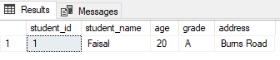

Scenario 2: Updating a student's age:
Code:
UPDATE Student
SET age = 16
WHERE student_id = 1;
Results:
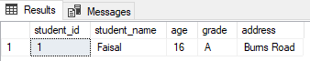

Scenario 3: Deleting a student record:

Code:
DELETE FROM Student
WHERE student_id = 1;

Results:

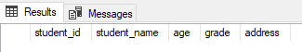

Scenario 4: Inserting multiple student records:
Code:
INSERT INTO Student VALUES
(2, 'Muhammad Faisal', 19, 'A', 'Bahadurabad'),
(3, 'Rehan', 16, 'B', 'Malir Cantt'),
(4, 'Farhan', 12, 'B+', 'Nipa'),
(5, 'Furqan', 19, 'A', 'Gulshan'),
(6, 'Abdul', 16, 'B', 'Bahria Town');

Results:
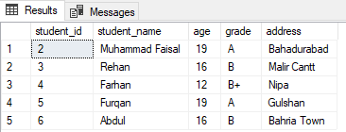

Scenario 5: Updating a student's grade:
Code:
UPDATE Student
SET grade = 'A+'
WHERE student_name = 'Muhammad Faisal';
Results:
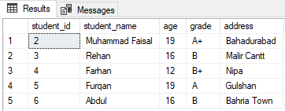

Scenario 6: Deleting all students with a grade of 'B':
Code:
DELETE FROM Student
WHERE grade = 'B';
Results:
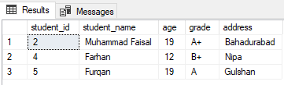

\

Scenario 7: Increase the age of all students by 1 year:
Code:
UPDATE Student
SET age = age + 1;
Results:
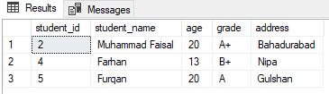

Scenario 8: Updating a student's address:
Code:
UPDATE Student
SET address = 'Malir'
WHERE student_name = 'Farhan';
Results:

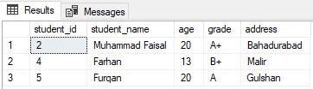

Scenario 9: Deleting all students younger than 15:
Code:
DELETE FROM Student
WHERE age < 15;

Results:
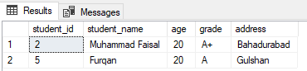

Scenario 10: Update the grade of the student with an ID of 5:
Code:
UPDATE Student
SET grade = 'A'
WHERE student_id = 5;

Results:
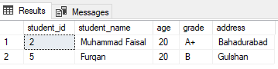

Lab #04

Data Retrieval Operations Using Select, Relationship
Among Tables Considering Constraints.

TASK:

create table dept(
dept_no int primary key,
dept_name varchar(50),
dept_loc varchar(50),
);

create table emp(
emp_no int primary key,
dept_no int foreign key(dept_no) references dept (dept_no),
emp_name varchar(50),
job varchar(50),
mgr int,
emp_salary decimal(7,2),
emp_comm decimal(7,2),
emp_phone int
);

• List all rows of the table emp.
Code:
SELECT * FROM emp;

Results:
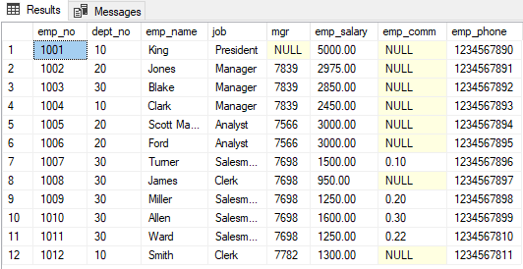

• List all rows of the dept.

Code:
SELECT * FROM dept;

Results:
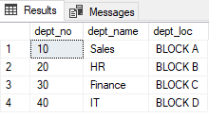

• List all employees’ number from emp.

Code:
SELECT emp_no FROM emp;

Results:
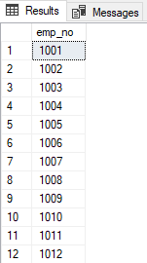

• List all employees name from emp.

Code:
SELECT emp_name FROM emp;
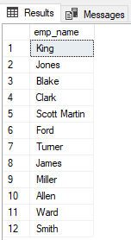
Results:

• List all departments’ number from emp.
Code:
SELECT dept_no FROM emp;

Results:
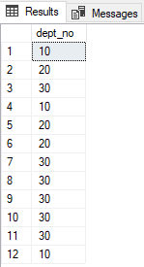

• Find all employees whose salaries are between 500 and 1500.
Code:
SELECT * FROM emp
WHERE emp_salary BETWEEN 500 AND 1500;

Results:
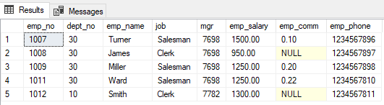

• Find all employees whose salaries are between 1500 and 2500.
Code:
SELECT * FROM emp
WHERE emp_salary BETWEEN 1500 AND 2500;

Results:
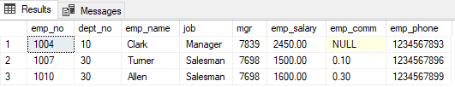

• Find all employees whose salaries are between 2600 and 5000.

Code:
SELECT * FROM emp
WHERE emp_salary BETWEEN 2600 AND 5000;

Results:
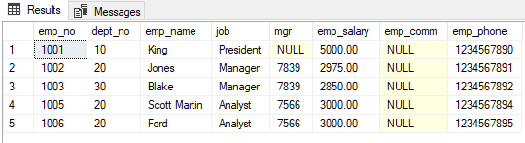

• Find all employees whose salaries are less than 2000.

Code:
SELECT * FROM emp
WHERE emp_salary<2000;

Results:
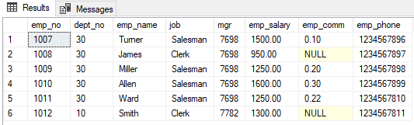

• Find all employees whose salaries are greater than 2000
Code:
SELECT * FROM emp
WHERE emp_salary>2000;

Results:
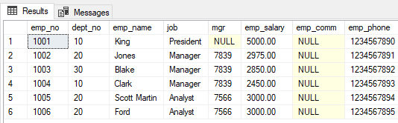

• Find those employees whose mgr are 7902, 7566, 7788.
Code:
SELECT * FROM emp WHERE mgr IN (7902, 7566, 7788);
Results:
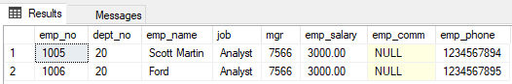

• Find those employees whose mgr is between 7788 and 7092.
Code:
SELECT * FROM emp WHERE mgr BETWEEN 7092 AND 7788;

Results:
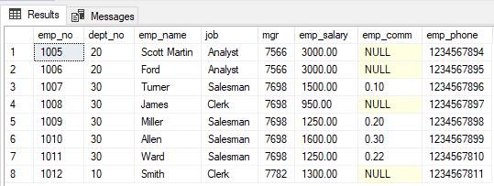

• List all employees whose name starts with ‘s’.
Code:
SELECT * FROM emp WHERE emp_name LIKE 'S%';

Results:
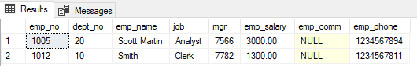

• List all employees whose name start with 'a'.
Code:
SELECT * FROM emp WHERE emp_name LIKE 'a%';

Results:
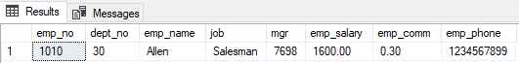

• List all employees having first name as 'scott’.
Code:
SELECT * FROM emp WHERE emp_name LIKE 'Scott%';

Results:
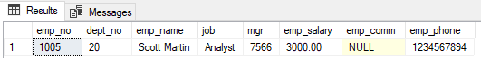

• List all employees having first name as ‘smith' or 'king'.
Code:
SELECT * FROM emp WHERE emp_name IN ('smith', 'king');

Results:
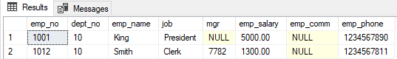

• List all employees having first letter in their name 'w' or 'k’ and they don’t belong to Department number 10,20 and 40.
Code:
SELECT * FROM emp WHERE (emp_name LIKE 'w%' OR emp_name LIKE 'k%')
AND dept_no NOT IN (10, 20, 40);

Results:
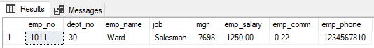

• List all employees whose name begin with 'scott’ and end with martin.
Code:
SELECT * FROM emp WHERE emp_name LIKE 'scott%martin';

Results:
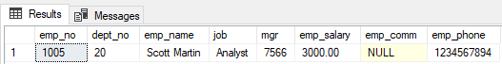

• List all employees whose name start with 'm' and belong to department number 30.
Code:
SELECT * FROM emp WHERE emp_name LIKE 'm%' AND dept_no = 30;

Results:
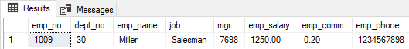

• List all employees whose name started with character 'b' and their jobs are manager.
Code:
SELECT * FROM emp WHERE emp_name LIKE 'B%' AND job ='Manager';

Results:
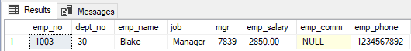

• List all employees who do not have job manager..
Code:
SELECT * FROM emp WHERE job != 'Manager';

Results:
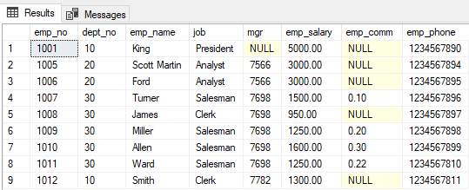

• Find those employees whose job do not start with ‘a’.
Code:
SELECT * FROM emp WHERE job not like 'A%';

Results:
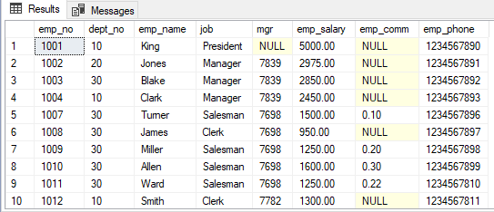

• Find those employees whose job does not start with 'c'.
Code:
SELECT * FROM emp WHERE job not like 'C%';

Results:
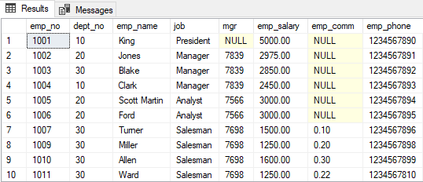

• List of those employees whose mgr is not null.
Code:
SELECT * FROM emp WHERE mgr IS NOT NULL;

Results:
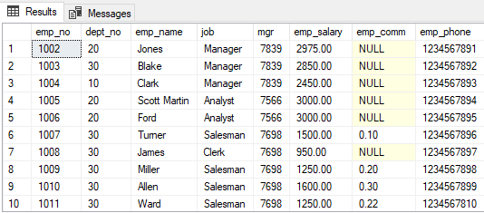

• List of those employees whose jobs are 'manager or clerk' of department number 10.
Code:
SELECT * FROM emp WHERE (job = 'manager' OR job = 'clerk') AND dept_no = 10;

Results:
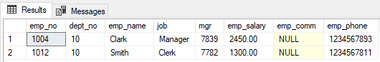

• List of those employees whose jobs are 'analyst' and 'salesman' of department 30.
Code:
SELECT * FROM emp WHERE job IN ('analyst', 'salesman') AND dept_no = 30;

Results:
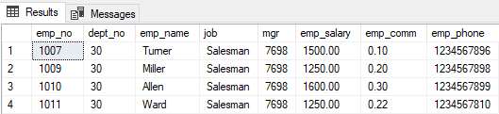

• Find all clerks who earn salaries between 1000 and 2000.
Code:
SELECT * FROM emp WHERE job ='Clerk' AND emp_salary between 1000 and 2000;

Results:
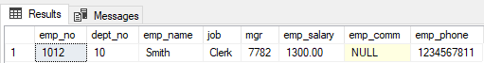
• Find all managers who earn salaries between 2500 and 3000.
Code:
SELECT * FROM emp WHERE job ='Manager' AND emp_salary between 2500 and 3000;

Results:
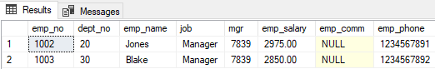

• Find all employees who are either clerk or 'manager' and all employees who earn Salaries in the range of 1000 and 2000.
Code:
SELECT * FROM emp WHERE (job ='Manager' or job ='Clerk')
OR (emp_salary between 1000 and 2000);

Results:
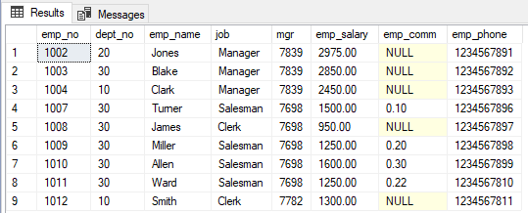

• Find all employees who are either manager and/or all employees who earn salaries between 2000 and 3000.

Code:
SELECT * FROM emp WHERE job ='Manager' or (emp_salary between 2000 and 3000);

Results:
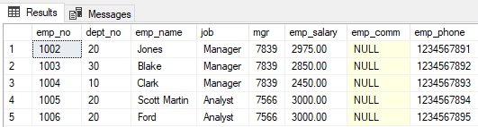

• Find all employees whose salaries are equal to 1500 and jobs are manager or salesmen.

Code:
SELECT * FROM emp WHERE emp_salary = 1500 AND (job = 'manager' OR job = 'salesman');

Results:
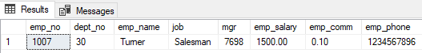

Lab #05

Data Retrieval Operations using Join operations

TASK 1:
- Consider the following relation
EMPLOYEE (EMP_ID, EMP_NAME, EMP_ADDRESS, SKILL, PROJ-ID). EQUIPMENT (EQP-ID, EMP_ID, EQP-TYPE, PROJECT).
Code:

CREATE TABLE employee(
emp_id INT PRIMARY KEY,
emp_name VARCHAR(50),
emp_address VARCHAR(50),
skill VARCHAR(50),
proj_id INT
);

CREATE TABLE equipment(
eqp_id INT PRIMARY KEY,
emp_id INT FOREIGN KEY (emp_id) REFERENCES employee(emp_id),
eqp_type VARCHAR(50),
project VARCHAR(50)
);

INSERT INTO employee VALUES
(1001,'Faisal','Burns Road','Developer',10),
(1002,'Ahmed','Nipa','Engineer',11),
(1003,'Ali','Malir','Designer',12)
;

INSERT INTO equipment VALUES
(110,1001,'Laptop','Mumbai Project'),
(111,1002,'Welding Machine','Renovation Project'),
(112,1003,'Laptop','Dubai Project')
;

Results:
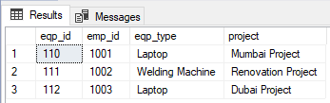
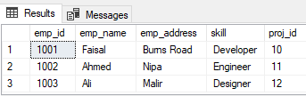

- Find the join of relations EMPLOYEE and EQUIPMENT.

Code:
SELECT * FROM employee
INNER JOIN equipment ON employee.emp_id=equipment.emp_id;

Results:
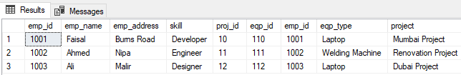

- Get all employees for projects using EQP-TYPE as a “Welding machine”.

Code:
SELECT employee.emp_id,employee.emp_name,equipment.eqp_id,equipment.eqp_type FROM employee
JOIN equipment ON employee.emp_id = equipment.emp_id
WHERE equipment.eqp_type = 'Welding Machine';

Results:
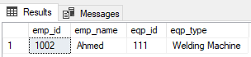
- Get all machines being used at the Mumbai Project?

Code:
SELECT employee.emp_id,employee.emp_name,equipment.project FROM equipment
JOIN employee ON employee.emp_id = equipment.emp_id
WHERE equipment.project='Mumbai Project';

Results:
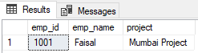
- Find all employees of the project using equipment number 110.

Code:
SELECT employee.emp_id,employee.emp_name,equipment.eqp_id FROM equipment
JOIN employee ON employee.emp_id = equipment.emp_id
WHERE equipment.eqp_id=110;

Results:
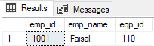

Task 2:

- Consider the following relation
SALESMAN (SALESMAN_ID, NAME, CITY, COMMISION)
CUSTOMER (CUSTOMER_ID, CUST_NAME, CITY, GRADE, SALESMAN_ID) ORDERS (ORD_NO, PURCH_AMT, ORD_DATE, CUSTOMER_ID, SALESMAN_ID).

Code:
CREATE TABLE salesman(
salesman_id INT PRIMARY KEY,
name VARCHAR(50),
city VARCHAR(50),
commision DECIMAL(7,2),
);

CREATE TABLE customer(
customer_id INT PRIMARY KEY,
cust_name VARCHAR(50),
city VARCHAR(50),
grade VARCHAR(50),
salesman_id INT FOREIGN KEY (salesman_id) REFERENCES salesman(salesman_id)
);

CREATE TABLE orders(
ord_no INT PRIMARY KEY,
purch_amt INT,
order_date date,
customer_id INT FOREIGN KEY (customer_id) REFERENCES customer(customer_id),
salesman_id INT FOREIGN KEY (salesman_id) REFERENCES salesman(salesman_id)
);
Results:

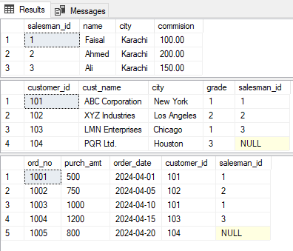
- Write a SQL statement to know which salesman are working for which customer.
Code:
SELECT s.NAME AS Salesman_Name, c.CUST_NAME AS Customer_Name
FROM SALESMAN s
INNER JOIN CUSTOMER c ON s.SALESMAN_ID = c.SALESMAN_ID;

Results:
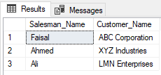
- Write a SQL statement to make a list in ascending order for the customer who works either through a salesman or by own.
Code:
SELECT CUST_NAME, CITY FROM CUSTOMER
ORDER BY SALESMAN_ID ASC, CUST_NAME ASC;

Results:

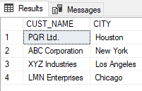
- Write a SQL statement to make a list in ascending order for the salesmen who works either for one or more customers or not yet joined under any of the customers.
Code:
SELECT s.salesman_id, s.name AS Salesman_Name FROM SALESMAN s
LEFT JOIN CUSTOMER c ON s.SALESMAN_ID = c.SALESMAN_ID
ORDER BY s.SALESMAN_ID ASC;

Results:

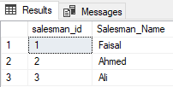

- Write a SQL statement to make a report with customer name, city, order no. order date, purchase amount for those customers from the existing list who placed one or more orders or which order(s) have been placed by the customer who are not in the list.

Code:
SELECT c.cust_name, c.city, o.ord_no, o.order_date, o.purch_amt
FROM CUSTOMER c
INNER JOIN ORDERS o ON c.customer_id = o.customer_id

UNION ALL

SELECT oc.cust_name, oc.city, o.ord_no, o.order_date, o.purch_amt
FROM ORDERS o
LEFT JOIN CUSTOMER oc ON o.customer_id = oc.customer_id
WHERE oc.customer_id IS NULL;

Results:

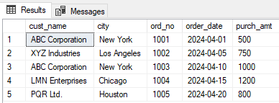

Lab #06

Single Row Functions & Aggregating Data Using Group Function

TASK:

CREATE TABLE EMP (
EMPNO INT PRIMARY KEY,
ENAME VARCHAR(100),
JOB VARCHAR(50),
MGR INT,
HIREDATE DATE,
SAL DECIMAL(10, 2),
COMM DECIMAL(10, 2),
DEPTNO INT FOREIGN KEY (DEPTNO) REFERENCES DEPT(DEPTNO)
);

CREATE TABLE DEPT (
DEPTNO INT PRIMARY KEY,
DNAME VARCHAR(50),
LOC VARCHAR(50)
);
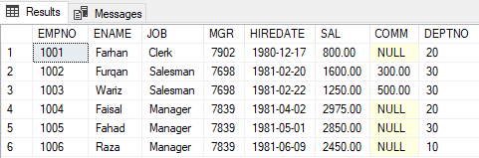
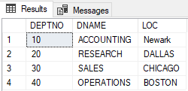

- Group the employees by their salaries.
Code:
SELECT SAL, COUNT(*) AS num_employees FROM EMP
GROUP BY SAL;

Results:
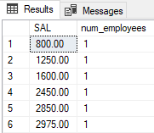

- List hiredates in descending order.
Code:
SELECT HIREDATE FROM EMP
ORDER BY HIREDATE DESC;

Results:
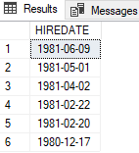

- List hiredates in ascending order
Code:
SELECT HIREDATE FROM EMP
ORDER BY HIREDATE ASC;

Results:
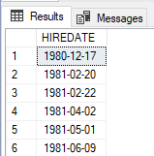
- List all employees and add 20 rupees in each salary.
Code:
SELECT EMPNO, ENAME, SAL, SAL + 20 AS INCREMENT FROM EMP;

Results:
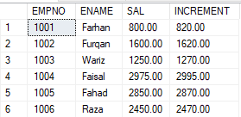
- List all 'manager' and add 100 rupees in each salary.
Code:
SELECT EMPNO, ENAME, SAL, SAL + 100 AS INCREMENT FROM EMP
WHERE JOB = 'Manager';

Results:
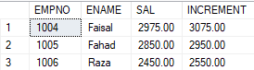

- List all 'salesman and add 500 rupees in each salary.
Code:
SELECT EMPNO, ENAME, SAL, SAL + 500 AS INCREMENT FROM EMP
WHERE JOB = 'Salesman';

Results:
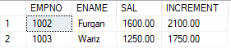
- List all 'clerk' and add 50 rupees in each salary.
Code:
SELECT EMPNO, ENAME, SAL, SAL + 50 AS INCREMENT FROM EMP
WHERE JOB = 'Clerk';

Results:
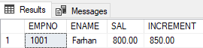

- Find eight percent of salesmen salary.
Code:
SELECT ENAME, SAL * 0.08 AS eight_percent_salary FROM EMP
WHERE JOB = 'Salesman';

Results:
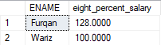
- Find the annual salary of each employee.
Code:
SELECT EMPNO, ENAME, SAL * 12 AS ANNUAL_SALARY FROM EMP;

Results:

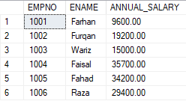
- Find the six-month salary of each employee.
Code:
SELECT EMPNO, ENAME, SAL * 6 AS SIX_MONTH_SALARY FROM EMP;

Results:
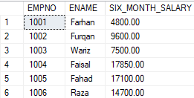

- Find the two-month salary of each manager.
Code:
SELECT EMPNO, ENAME, SAL * 2 AS TWO_MONTH_SALARY FROM EMP
WHERE JOB = 'Manager';

Results:
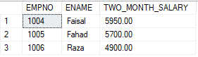
- Make a query in which all the arithmetic expressions will include all the result will be remain same.
Code:
SELECT EMPNO, ENAME, SAL * 1 AS SALARY FROM EMP;

Results:
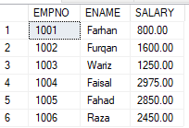
- Find the daily wages of each employee.
Code:
SELECT EMPNO, ENAME, SAL / 30 AS DAILY_WAGES FROM EMP;

Results:
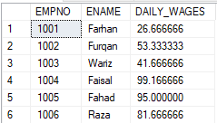

- Find the daily wages of each 'manager.
Code:
SELECT EMPNO, ENAME, SAL / 30 AS DAILY_WAGES FROM EMP
WHERE JOB = 'Manager';

Results:
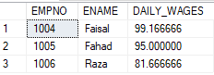
- Display your name in lowercase.
Code:
SELECT LOWER('MUHAMMAD FAISAL') AS lower_case_name;

Results:
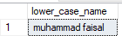
- Find the first and second characters of enames.
Code:
SELECT SUBSTRING(ENAME, 1, 2) AS first_two_characters FROM EMP;

Results:
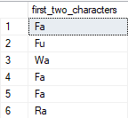
- Find the minimum salary from the table emp.
Code:
SELECT MIN(SAL) AS min_salary FROM EMP;

Results:
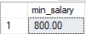
- Find the maximum salary from the table emp.
Code:
SELECT MAX(SAL) AS max_salary FROM EMP;

Results:
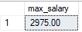
- Find the length of all ename.

Code:
SELECT ENAME, LEN(ENAME) AS ename_length FROM EMP;
Results:
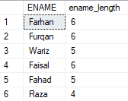

- Find the length of job.

Code:
SELECT JOB, LEN(JOB) AS job_length FROM EMP;

Results:
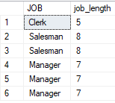
- Find the sum of all salaries.
Code:
SELECT SUM(SAL) AS total_salary FROM EMP;

Results:
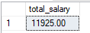
- Find those employees whose department location is Newark.
Code:
SELECT * FROM EMP
WHERE DEPTNO = (
SELECT DEPTNO FROM DEPT
WHERE LOC = 'Newark'
);

Results:
- Find those employees who are working in accounting department.
Code:
SELECT * FROM EMP
WHERE DEPTNO = (
SELECT DEPTNO FROM DEPT
WHERE DNAME = 'ACCOUNTING'
);

Results:

- Count all employees.
Code:
SELECT COUNT(*) AS num_employees FROM EMP;

Results:
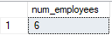

- Display the sum of all employees’ salaries.
Code:
SELECT SUM(SAL) AS total_salary FROM EMP;

Results:
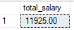
- How many managers do we have?
Code:
SELECT COUNT(*) AS num_managers FROM EMP
WHERE JOB = 'Manager';

Results:
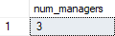

- How many departments do we have?
Code:
SELECT COUNT(DISTINCT DEPTNO) AS num_departments FROM EMP;

Results:
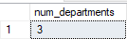

- List average salary of each job.
Code:
SELECT JOB, AVG(SAL) AS avg_salary FROM EMP
GROUP BY JOB;

Results:
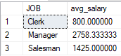
- Find the Maximum and Minimum salary of all employees.
Code:
SELECT MAX(SAL) AS max_salary, MIN(SAL) AS min_salary FROM EMP;

Results:
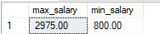

- Find the average salaries of those employees who work in dept 10.
Code:
SELECT AVG(SAL) AS avg_salary_dept_10 FROM EMP
WHERE DEPTNO = 10;

Results:
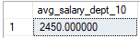

- Find average and sum of all the salaries of each job excluding clerks.
Code:
SELECT JOB, AVG(SAL) AS avg_salary, SUM(SAL) AS sum_salary FROM EMP
WHERE JOB != 'Clerk'
GROUP BY JOB;

Results:
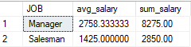
- Find the minimum and average salary of each department excluding deptno 10.
Code:
SELECT DEPTNO, MIN(SAL) AS min_salary, AVG(SAL) AS avg_salary FROM EMP
WHERE DEPTNO != 10
GROUP BY DEPTNO;

Results:
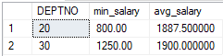

Lab #07

Implementing Cardinalities (minimum, maximum) and Mapping
Constraints on Multiple Tables

TASK:
Daraz is a popular shopping portal and all of us are familiar with its working mechanism . Implement above relations on to following tables of Daraz .
Orders
Product
Seller
Customer

Code:
CREATE TABLE Customer (
customer_id INT PRIMARY KEY,
cust_name VARCHAR(50),
cust_address VARCHAR(50),
cust_city VARCHAR(50)
);

CREATE TABLE Seller (
seller_id INT PRIMARY KEY,
seller_name VARCHAR(50),
seller_address VARCHAR(50),
seller_city VARCHAR(50)
);

CREATE TABLE Product (
product_id INT PRIMARY KEY,
product_name VARCHAR(50),
price DECIMAL(10, 2),
p_description VARCHAR(50),
seller_id INT FOREIGN KEY(seller_id) REFERENCES Seller(seller_id),
);
CREATE TABLE Orders (
order_id INT PRIMARY KEY,
purch_amt DECIMAL(10, 2),
order_date DATE,
cart_id INT FOREIGN KEY(cart_id) REFERENCES Cart(cart_id),
);

CREATE TABLE CART(
cart_id INT PRIMARY KEY,
product_id INT FOREIGN KEY(product_id) REFERENCES product(product_id),
customer_id INT FOREIGN KEY(customer_id) REFERENCES Customer(customer_id)
);

Results:

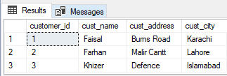
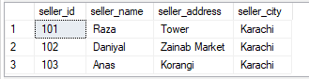

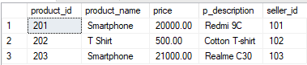
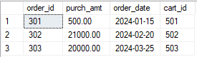

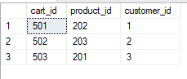

ER Diagram

product_id
cust_address
p_description
product_name
cust_name
product_id
customer_id
customer_id

price

Adds to cart
Product
Customer

Seller_id
cart_id
cust_city

Places
Sells

cart_id
Seller
Order

seller_id

seller_city
seller_name

seller_address
order_date
order_id

purch_amt

Lab #08

Sub-Queries In Sql

TASK:
CREATE TABLE EMP (
EMPNO INT PRIMARY KEY,
ENAME VARCHAR(50),
JOB VARCHAR(50),
MGR INT,
HIREDATE DATE,
SAL DECIMAL(10, 2),
DEPTNO INT FOREIGN KEY (DEPTNO) REFERENCES DEPT(DEPTNO)
);
CREATE TABLE DEPT (
DEPTNO INT PRIMARY KEY,
DNAME VARCHAR(50),
LOC VARCHAR(50)
);
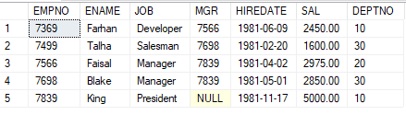
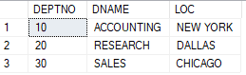

• Write a query to display the employee name and hiredate for all employees in the same department as Blake. Exclude Blake.
Code:
SELECT EMPNO,HIREDATE FROM EMP
where DEPTNO=(SELECT DEPTNO FROM EMP WHERE ENAME='Blake')
AND ENAME != 'Blake';

Results:
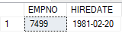

• Create a query to display the employee number and name for all employees who earn more than the average salary.

Code:
SELECT EMPNO, ENAME,SAL FROM EMP
WHERE SAL > (SELECT AVG(SAL) from EMP)

Results:
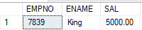

• Write a query to display the employee number and name for all employees who work in a department with any employee whose name contains a T.

Code:
SELECT EMPNO, ENAME
FROM EMP WHERE DEPTNO IN (
SELECT DISTINCT DEPTNO FROM EMP
WHERE ENAME LIKE '%T%'
);

Results:
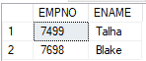
• Display the employee name, department number, and job title for all employees whose department location is Dallas.
Code:
SELECT EMPNO, DEPTNO,JOB FROM EMP
WHERE DEPTNO=(SELECT DEPTNO FROM DEPT
WHERE LOC='DALLAS');

Results:
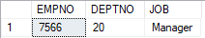

• Display the employee name and salary of all employees who report to King.
Code:
SELECT ENAME, SAL FROM EMP
WHERE MGR=(SELECT EMPNO FROM EMP
WHERE ENAME='King');

Results:
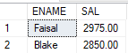

• Write a query to display the employee name, salary, deptno and job for all employees in the same job as empno 7369.

Code:
SELECT ENAME, SAL,DEPTNO,JOB FROM EMP
WHERE JOB=(SELECT JOB FROM EMP
WHERE EMPNO=7369);

Results:
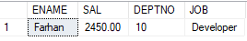

• Display the employee number, name and salary for all employees who earn more than the average salary and who work in department with any employee with a T in their name.
Code:
SELECT EMPNO,ENAME, SAL FROM EMP
WHERE SAL>(SELECT AVG(SAL) FROM EMP)
AND DEPTNO IN (
SELECT DISTINCT DEPTNO
FROM EMP
WHERE ENAME LIKE '%T%'
);

Results:
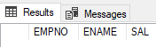

Lab #09

Retrieving Data from Multiple Tables, Mapping of shared data SQL

TASK:
CREATE TABLE departments (
deptno INT PRIMARY KEY,
dname VARCHAR(50),
loc VARCHAR(50)
);
CREATE TABLE employees (
empno INT PRIMARY KEY,
ename VARCHAR(50),
job VARCHAR(50),
mgr INT,
hiredate DATE,
sal DECIMAL(10, 2),
comm DECIMAL(10, 2),
deptno INT,
FOREIGN KEY (deptno) REFERENCES departments(deptno)
);

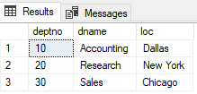
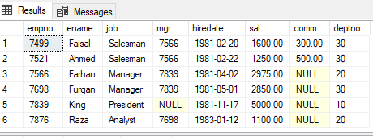

• To display the employee name, department name, and location of all employees who earn a commission.
Code:
SELECT E.ename, D.dname, D.loc
FROM employees E, departments D
WHERE E.deptno=D.deptno AND E.comm IS NOT NULL;

Results:
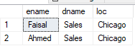

• To display all the employee’s name (including KING who has no manager) and their manager name

Code:
SELECT emp.ename AS employee_name, mgr.ename AS manager_name
FROM employees emp
LEFT JOIN employees mgr ON emp.mgr = mgr.empno;

Results:
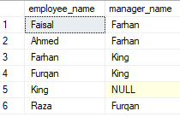

• To display the name of all employees whose manager is KING.
Code:
SELECT emp.ename AS employee_name, mgr.ename AS manager_name
FROM employees emp
JOIN employees mgr ON emp.mgr = mgr.empno
where mgr.ename= 'King';

Results:
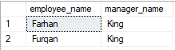

• Write a query to display the name, job, department number and department name for all employees who work in New York
Code:
SELECT E.ename AS employee_name, E.job, E.deptno, D.dname AS department_name
FROM employees E
JOIN departments D ON E.deptno = D.deptno
WHERE D.loc = 'New York';

Results:
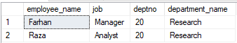

• Display the employee name and employee number along with their manager’s name Manager Number. Label the columns Employee, Emp#, Manager, and Manager#, respectively
Code:
SELECT emp.ename AS employee, emp.empno AS emp#, mgr.ename AS manager, mgr.empno AS manager#
FROM employees emp
LEFT JOIN employees mgr ON emp.mgr = mgr.empno;

Results:
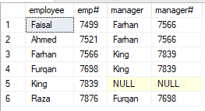
• Create a unique listing of all jobs that in department 30. Include the location of department 30 in the Output.
Code:
SELECT DISTINCT E.job, D.loc
FROM employees E
JOIN departments D ON E.deptno = D.deptno
WHERE E.deptno = 30;

Results:
